LOAD TEST AND FINDING BOTTLENECK OR ERROR ON <HTTPS://REQRES.IN>

**Description**

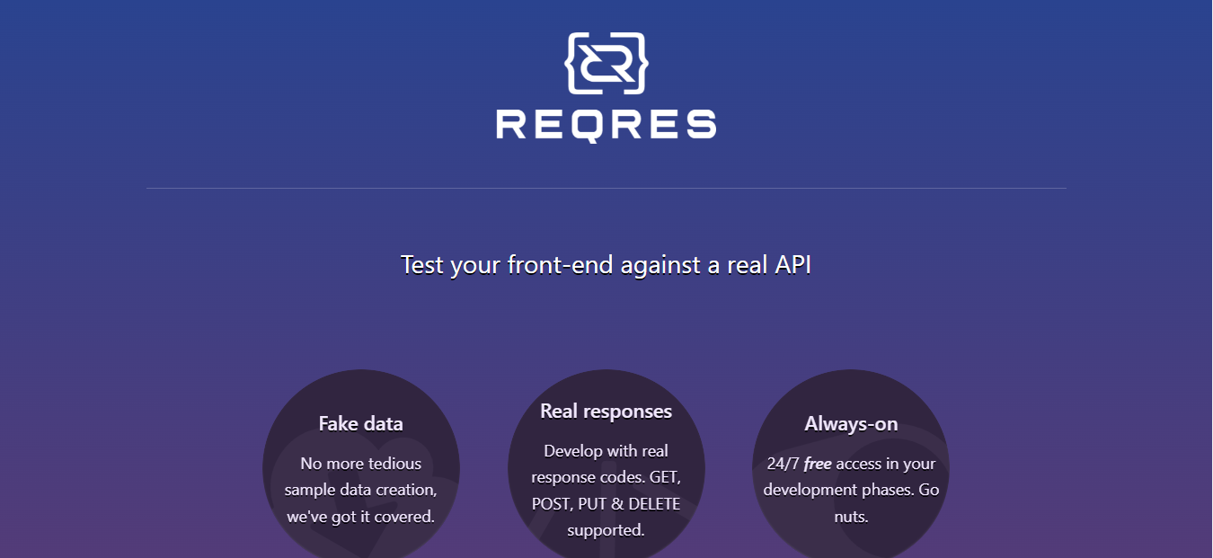The purpose of this test is to test endurance of API from website <https://reqres.in> using 1000 ccu and 2000 ccu as a load and look for errors or bottleneck will occur in the API by using Jmeter and Locust.

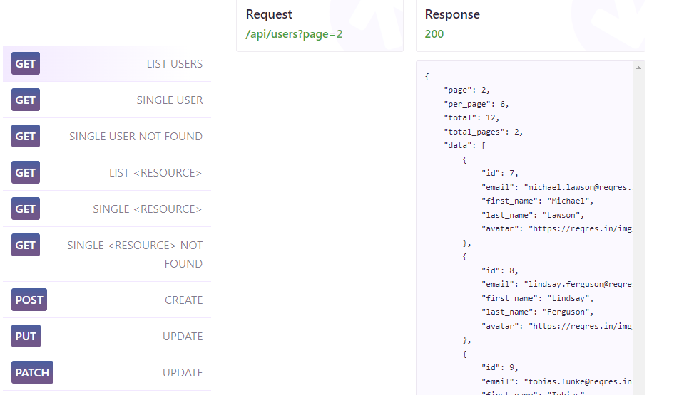

**Front page of website https://reqres.in**

**API provided by** [**https://reqres.in**](https://reqres.in)

**Action**

To perform this test, you can use Jmeter and Locust which are run through Windows Visual Code.

To compare the results of the load test, the experiment was carried out at two different stages. The first stage is load testing using jmeter and the second stage is using locust.

**Result and Explanation**

The following are the results and explanations obtained from the load testing process using 2 different loads, specifically by using a 1000 ccu load and 2000 load on jmeter and locust.

* **1000 CCU**

1. Jmeter Screenshoot

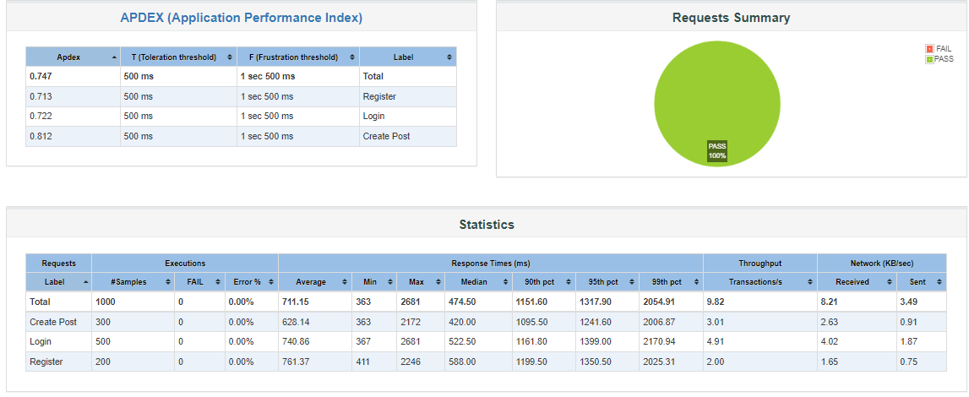

1. Locust Screenshot

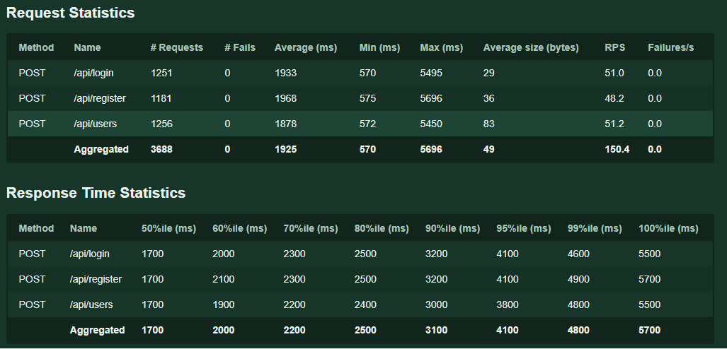

In the summary table of Jmeter at 1000 ccu load, it can be seen that when the API transaction was at the 1000 ccu level, no errors were found either in Register, Login or Create Post. However, the difference that can be seen in the table occurs in the number of different average response times at 1000 ccu and 2000 ccu loads, specifically at 1000 ccu the average response tume is only 711.15 ms in jmeter while on locust it reach to 1700 ms at 50% response time. Meanwhile, on 99%ile on Jmeter, 1000 ccu load reach to 893.35ms and at 100% response time on locust it reach to 5700 ms and does not cause bottlenecks or errors.

* 2000 load

1. Jmeter Screenshoot

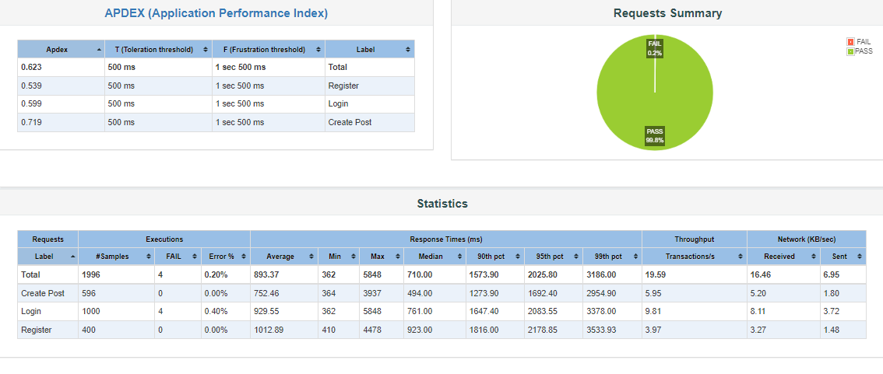

1. Locust Screenshoot

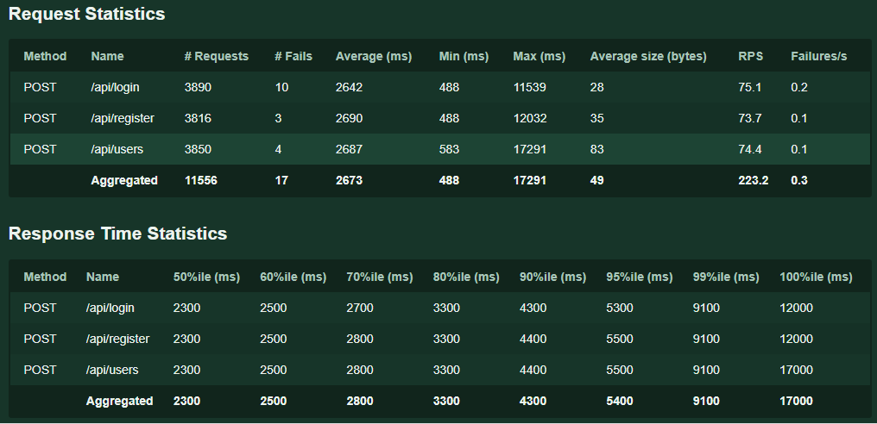

At load test on 2000 ccu load there is a big difference between testing on jmeter and locust. At jmeter on load 2000 ccu it reach 893.37 ms on average response time and 2054.91 ms at locust. At 99% on jmeter it reach 5700 and on locust it reach 17000 both doesn’t cause a bottleneck or error. In the summary table on locust there is fail attempt of response time that caused by force stop because if we did not forcely stopped the program it keeps spawning the test with user until the test failed.

**Conclusion**

Based on observations made from load testing on two different applications, it appears that the high response time results that occur at 100% response time does not redusce the resilience and capability of the APU provided by <https://reqres.in>. The high rate of 100% response time that occurs in 2000 ccu does not cause errors or bottlenecks. So, this website has a capability of affording to more than 2000 user per day.